

**FPT ACADEMY INTERNATIONAL**

## FPT – APTECH COMPUTER EDUCATION

|  |  |  |  |
| --- | --- | --- | --- |
| **Center Name:** | FPT – Aptech – HCM2 | | |
|  | Address:590 Cach Mang Thang Tam,  District 3, Ho Chi Minh City | | |
| **Instructor:** | Ms. Le Mong Thuy | | |
|  |  | | |
| **Class:** | T1.2208.A0 | | |
| **Group:** | 07 | | |
| **Group members** | **Name**  Nguyen Anh Duy | | **Student ID**  Student1408049 | |
|  | Le Tan Kha | | Student1408043 | |
|  | Le Thi Hoa Dang | | Student1405212 | |
|  |  | |  | |
| **Project Duration** | Start date | Nov 14th 2022 | | |
|  | End date | Dec 14th 2022 | | |

**This is to certify that**

Nguyen Anh Duy

Le Tan Kha

Le Thi Hoa Dang

**has successfully designed & developed**

eProject: RYAN Sports Club

**Submitted by:**

Nguyen Anh Duy

**Date of issue:** Nov 14th 2022

**Authorized Signature:**







**FPT-APTECH COMPUTER EDUCATION 1**

**ACKNOWLEDGMENT 3**

**SYNOSIS 3**

**PROBLEM DEFINITION 3**

**CUSTOMER’S REQUIREMENTS SPECIFICATION (CRS) 4**

**Business/project Objective 4**

**Hardware/software Requirements 5**

**SCOPE OF THE WORK (IN BRIEF) 6**

**Architecture and design of the system 7**

**Diagram of website 8**

**TASK SHEET REVIEW 1 9**

**SITE MAP 10**

**MOCK OF THE WEBSITE 11**

1. **Home page 11**
2. **Shop 12**
3. **Features 13**
4. **Gallery 14**
5. **Logo 15**
6. **About us 16**
7. **Contact us 17**
8. **Member 18**

**TASK SHEET REVIEW 2 19**

**WEBSITE DESCRIPTION 20**

1. **Home page 20**
2. **Shop 21**
3. **Product categories 21**
4. **Features 22**
5. **Gallery 23**
6. **About us 24**
7. **Contact us 25**
8. **Member 26**

**JAVASCRIPT DESCRIPTION 27**

1. **Product data json and JavaScript 27**
2. **Filter JavaScript 30**
3. **Comparison JavaScript 31**
4. **Add to cart JavaScript 34**
5. **Contact us JavaScript 35**

**TASK SHEET REVIEW 3 36**



## ACKNOWLEDGMENT

On behalf of all the members of group 7, I would like to thank you all for the hard works, support to make this eProject complete successfully. Especially Ms. Le Mong Thuy, our teacher, she helped us a lot from the day that we started to study at FPT Aptech. With this eProject, she has guided us with her enthusiasm and rigor. Because of her guidance, we would be able to finish this project. Besides, I want to thank all the team members of group 4, each of the team members has been working continuously in 4 weeks in order to complete this project. Last but not least, we would like to say thank you to our family for always supporting us, creating the best conditions for us to focus on the project, and putting faith in the dreams we pursue.

**SYNOSIS**

In this task, we are assigned to design and develop a business website which meets all the requirements from our client under the name RYAN Sports Club. The business is all about promoting sports and a healthy lifestyle for its customers. Client's goal for the website is to bring convenience to customers who can easily View our facilities and activities in detail.

**PROBLEM DEFINITION**

RYAN Sports Club, an effort has been made to provide world class facilities and infrastructure for the promotion of sports and health. During the past, RYAN sports club has emerged as one of the best facilities in the country in the area of sports and health and also it is making strides to acquire a formidable presence internationally. The club provides facilities like “Indoor Sports”, “Outdoor Sports” and “Recreation”. All this information is required to be presented in organized form for which a website is required to be created.

The website is to be developed for the Windows Platform using HTML5, JavaScript and Geolocation. The site should work well in all leading browsers including Chrome, IE, Firefox etc.



## CUSTOMER'S REQUIREMENTS SPECIFICATIONS (CRS)

Client: RYAN Sports Club

Business/Project Objective:

In this task, we are assigned to design and develop a business website which meets all the requirements from our client under the name RYAN Sports Club. The business is all about promoting sports and a healthy lifestyle for its customers. Client's goal for the website is to bring convenience to customers who can easily View our facilities and activities in detail.

You are supposed to create a website for them with the below mentioned requirement specifications.

### Input to the system:

* Membership sign-in, sign-up page
* Contact Page
* Feedback page

### Output from the system:

* A homepage with a description about the club + navigational links
* Display facilities (indoor, outdoor, recreational)
* List of activities arranged yearly.
* Picture gallery
* Information about each sport
* Top sport persons.
* The location of the Club under the Contact Us page.

### Process:

* Sign in; sign up (validate)

**Expected delivery date:** 14th-Nov-2022



### List of deliverables:

* + Document Word.
  + Source code.

**Hardware/ Software Requirements:**

**For developer**

**Hardware**

Intel Pentium 4 processor or higher 1 Gigabytes of RAM or higher

**Software**

Windows 7 OS or higher Adobe Dreamweaver

Web browsers such as IE, Chrome or Firefox are supporting HTML5, CSS3 and JavaScript.

**For web users**

**Hardware**

Intel Pentium 4 processor or higher 1 Gigabytes of RAM or higher

**Software**

Windows 7 OS or higher

Web browsers such as IE, Chrome or Firefox are supporting HTML5, CSS3 and JavaScript.



## SCOPE OF THE WORK (IN BRIEF)

After a long and detailed discussion, our group has decided to create a website contain the following webpages:

1. **Homepage**: We divided the section into 3 parts:
   * *Part 1 header: main links, “Visit us to know more”*
   * *Part 2 body: activities, facilities, benefits section to provide info of the club to the customer*

- *Part 3 footer: small contact us part at the bottom, copyright*

1. **Activities**: Displays the activities from Indoor, Outdoor, to Recreational Sports.

* Fitness(indoor)
* volleyball(indoor)
* Swimming(indoor)
* Basketball(outdoor)
* Soccer(outdoor)
* Tennis(outdoor)
* Sauna(indoor)
* Mediation(indoor)

1. **Membership**: Displays a log-in and sign-up page.

### Feedback

1. **Picture Gallery**
2. **Contact Us**: Displays phone number, email, location (Geolocation API).
3. **About**: Display business contacts (address, phone, email, map).



# Architecture and design of the system

Webpage request



**Diagram of the website**

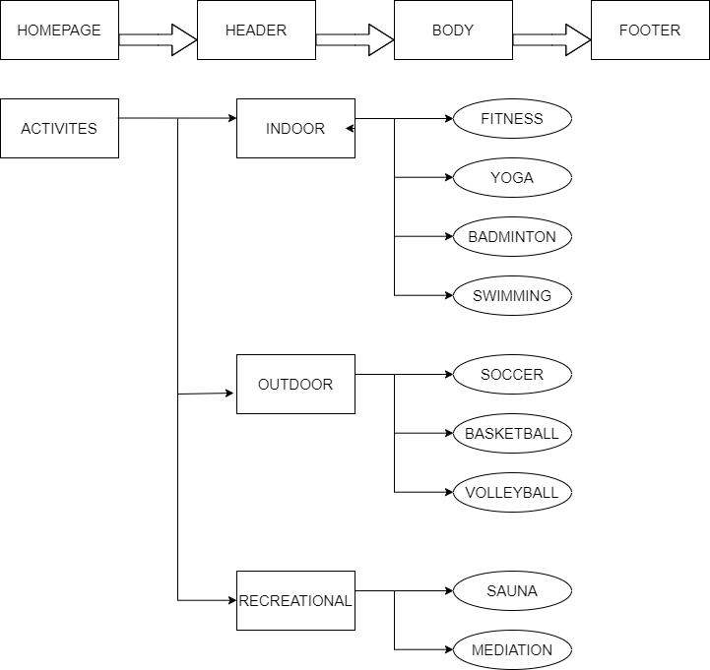

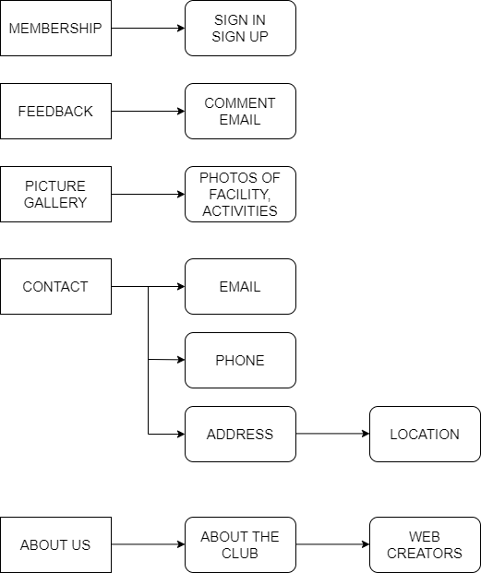



# TASK SHEET REVIEW 1

|  |  |  |  |  |  |  |  |
| --- | --- | --- | --- | --- | --- | --- | --- |
| **Project Ref. No.:**  **eP/Advertisement Portal Management**  **System/01** | | **Project Title:** | **Activity Plan Prepared By:** | **Date of Preparation of Activity Plan:** | | | |
| **Sr.**  **No.** | **Task** | **Actual Start**  **Date** | **Actual Days** | **Team Mate Names** | **Status** |
| 1 | Problem Statement | RYAN SPORTS CLUB | Nguyen Anh Duy | 14-Nov-22 | 1 | Nguyen Anh Duy | Completed |
| 2 | Analysis of RYAN Sports Club requirements about  the website | 14-Nov-22 | 1 | Nguyen Anh Duy | Completed |
| 3 | The scope of the work (in  brief) | 14-Nov-22 | 1 | Le Thi Hoa Dang | Completed |
| 4 | Architecture and design  of the system | 14-Nov-22 | 1 | Le Thi Hoa Dang | Completed |
| 5 | Diagram of the website | 14-Nov-22 | 1 | Le Tan Kha | Completed |
| 6 | Task Sheet | 14-Nov-22 | 1 | Le Tan Kha | Completed |

|  |  |
| --- | --- |
| **Date: 14th Nov 2022** | |
| Signature of Instructor:  **Ms. Le Mong Thuy** | Signature of Team Leader:  **Nguyen Anh Duy** |



**MOCK OF THE WEBSITE**

### Homepage

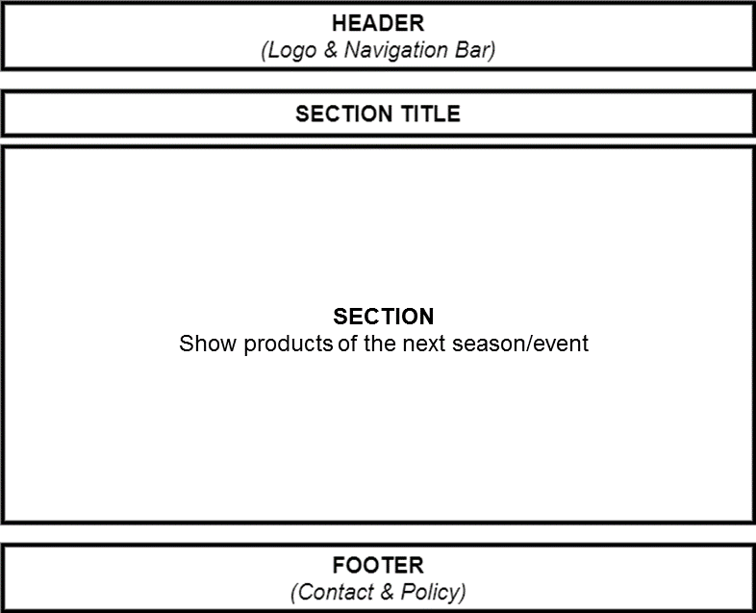

1. **Activities**

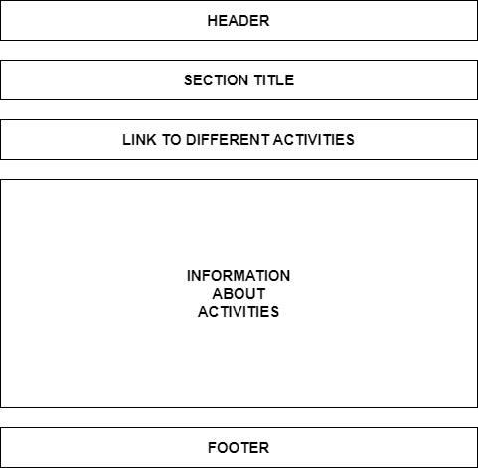

### Gallery



1. **Logo**

This logos designed by Le Thi Hoa Dang - Student1405212

### Contact

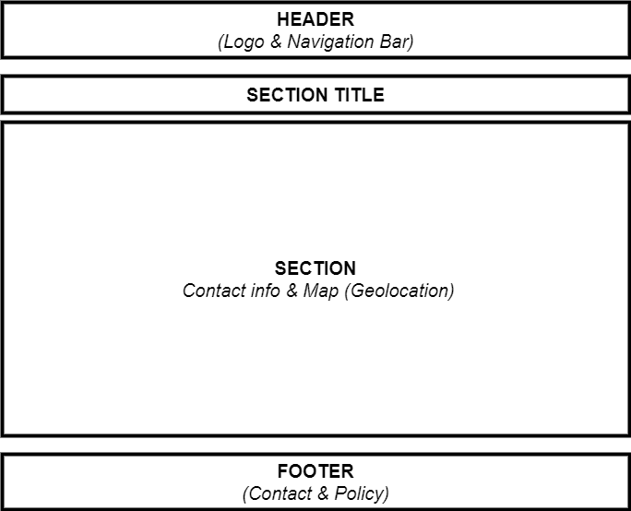

### About Us

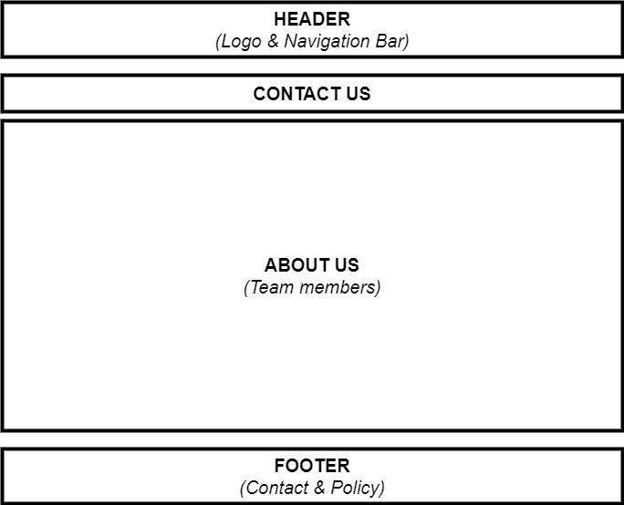

1. **Membership**

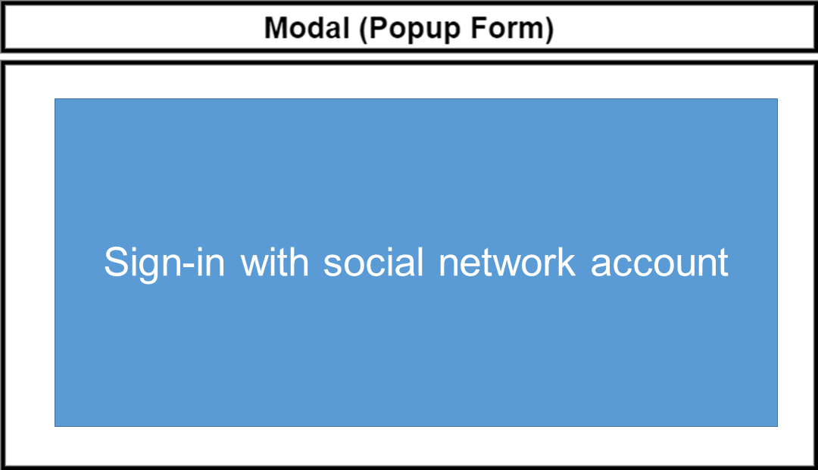

# TASK SHEET REVIEW 2

|  |  |  |  |  |  |  |  |
| --- | --- | --- | --- | --- | --- | --- | --- |
| **Project Ref. No.: eP/Advertisement**  **Portal Management**  **System/01** | | **Project Title:** | **Activity Plan Prepared By:** | **Date of Preparation of Activity Plan:** | | | |
| **Sr.**  **No.** | **Task** | **Actual Start Date** | **Actual Days** | **Team Mate Names** | **Status** |
| 1 | Site map | RYAN  Sports Club | Nguyen  Anh Duy | 14th-Nov-2022 | 1 | Nguyen Anh Duy | Completed |
| 2 | Mock of the website | 14th-Nov-2022 | 2 | Nguyen Anh Duy | Completed |
| 3 | Task sheet | 14th-Nov-2022 | 2 | Nguyen Anh Duy | Completed |

|  |  |
| --- | --- |
| **Date: 14th Nov 2022** | |
| Signature of Instructor:  **Ms. Le Mong Thuy** | Signature of Team Leader:  **Nguyen Anh Duy** |

## WEBSITE DESCRIPTION

* 1. **Home page**
     1. Description

Home page displays following information

* + - * Activities
      * Membership
      * Contact
      * Feedback
      * Gallery
      * About Us
      * Sign In
    1. Screenshot

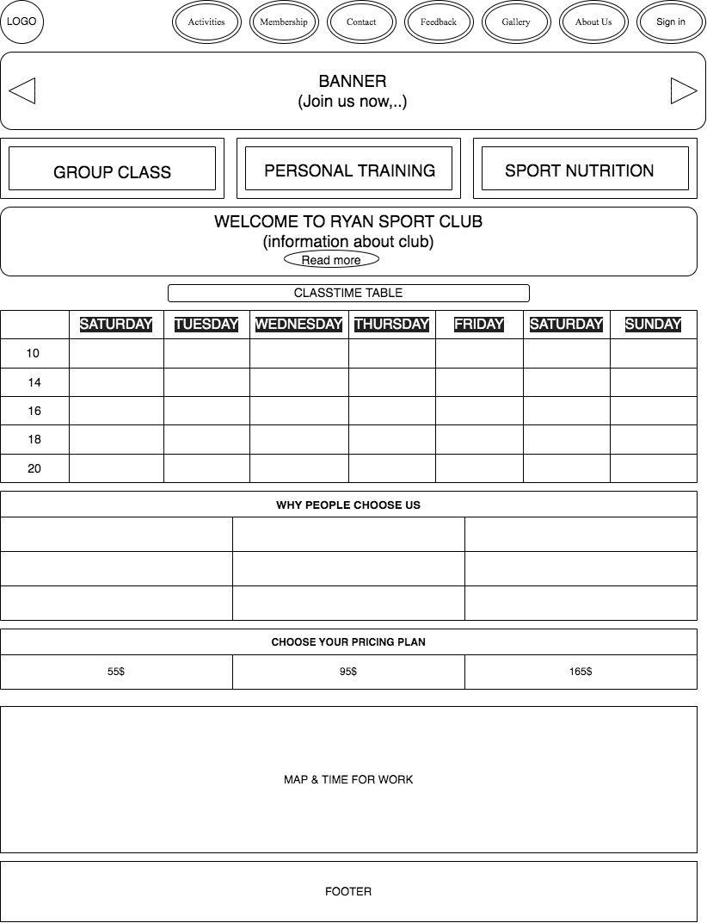

* 1. **Activities**
     1. Description

Activities page displays following information

* + - * Indoor activities
      * Outdoor activities
      * Recreation activities
      * Description about each activities displayed
      * Footer (contact and policy)
    1. Screenshot

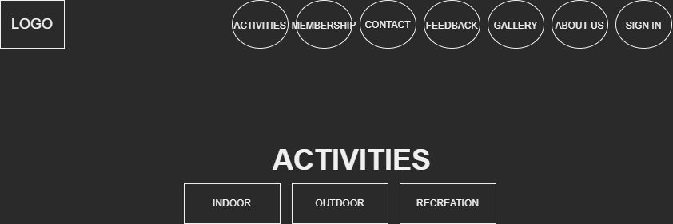

* 1. **Membership**
     1. Sign up Form

Membership page displays following information

* + - * Sign Up Form
      * When signed in will alert message (“Sign Up Success”)+
    1. Screenshot

sign up

* 1. **Feedback**
     1. Description

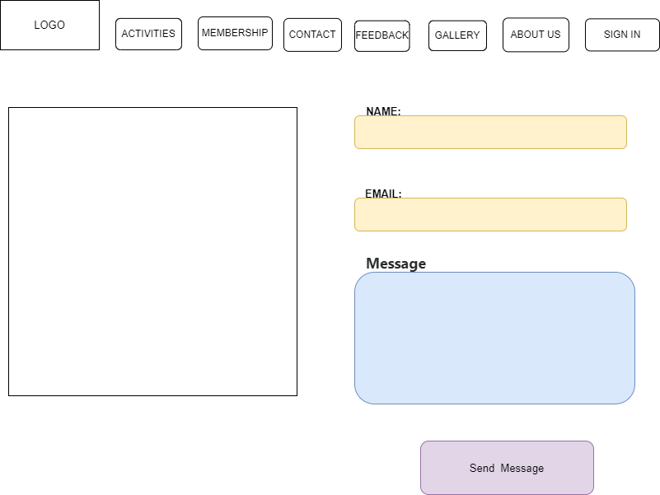Contact page displays a ma

* 1. **Gallery**
     1. Description

This page will display Images of the sports and facilities of Ryan Sports Club

* + 1. 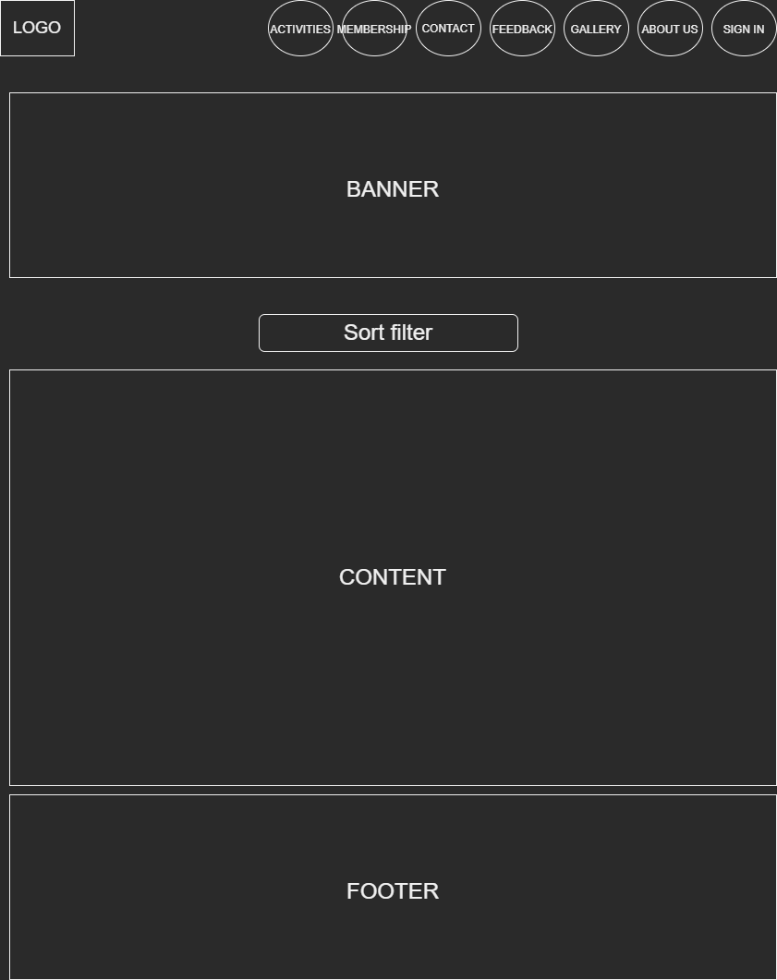Screenshot
  1. **About us**
     1. Description

This page will display information about the history of RYAN SPORT CLUB, our service that we provide and our team members.

* + 1. Screenshot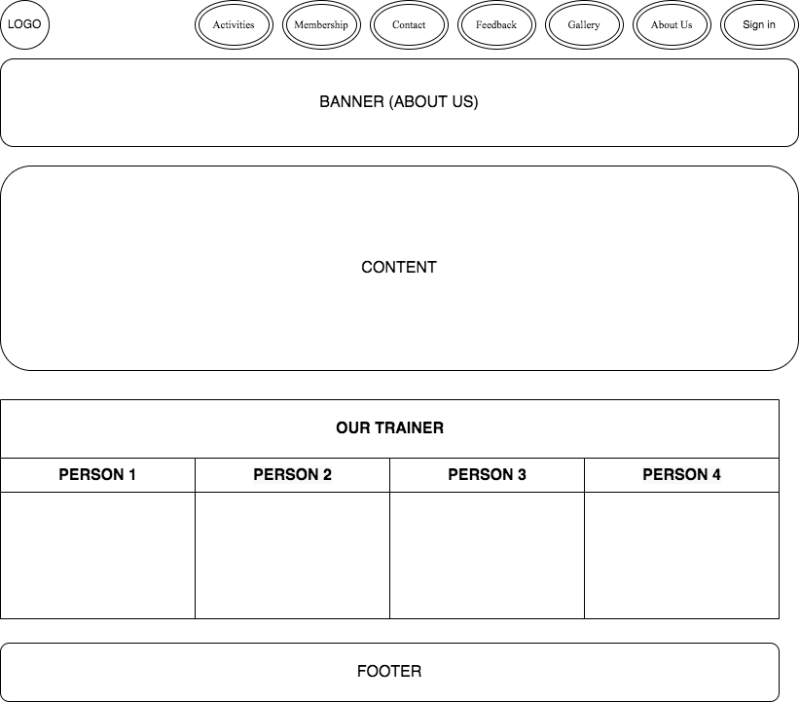
  1. **Sign in**

1. Description

This page will display information about sign in.

1. Screenshot

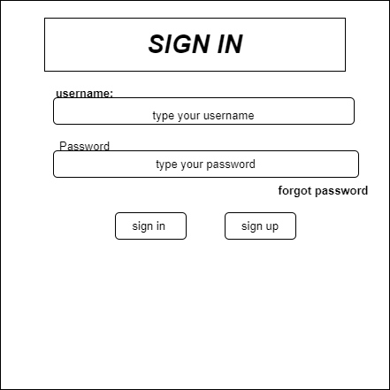

## JAVASCRIPT DESCRIPTION

1. **Product data json and JavaScript.**
   1. Description

This script is used for adding product detail.

* 1. Screenshot
     1. Product data json
     2. JavaScript
     3. Modal show item’s detail

1. **Filter JavaScript**
   1. Description

This script used for filtering items in the sport club page.

* 1. Screenshot

1. **Comparison JavaScript**
   1. Description

This script used for comparing items in the sport club page.

* 1. Screenshot

1. **Add to Cart JavaScript**
   1. Description

This script used for adding items to cart and show how many item added.

* 1. Screenshot

1. **Contact us JavaScript**
   1. Description

This script used for contacting our customer service.

* 1. Screenshot

# TASK SHEET REVIEW 3

|  |  |  |  |  |  |  |  |
| --- | --- | --- | --- | --- | --- | --- | --- |
| **Project Ref. No.: eP/Advertisement**  **Portal Management**  **System/01** | | **Project Title:** | **Activity Plan Prepared By:** | **Date of Preparation of Activity Plan:** | | | |
| **Sr.**  **No.** | **Task** | **Actual Start Date** | **Actual Days** | **Team Mate Names** | **Status** |
| 1 | Website layout | RYAN Sports Club | Nguyen Anh Duy | 14th-Nov-2022 | 5 | Le Thi Hoa Dang | Incomplete |
| 2 | Edit CSS | 14th-Nov-2022 | 5 | Le Thi Hoa Dang | Incomplete |
| 3 | Modal JavaScript | 14th-Nov-2022 | 5 | Nguyen Anh Duy | Incomplete |
| 4 | Filter & comparison JavaScript | 14th-Nov-2022 | 5 | Nguyen Anh Duy | Incomplete |
| 5 | Product detail and data  JSON | 14th-Nov-2022 | 3 | Le Tan Kha | Incomplete |
| 6 | Task sheet review | 14h-Nov-2022 | 3 | Le Tan Kha | Incomplete |

|  |  |
| --- | --- |
| **Date: 14th Nov 2022** | |
| Signature of Instructor:  **Ms. Le Mong Thuy** | Signature of Team Leader:  **Nguyen Anh Duy** |